Make & Trade

BRD

Introduced By Group 18

# Introduction

# Executive Summary

Make & Trade is an online market for handmade crafts. In Make & Trade users can sell their handmade products , share their experience by uploading tutorials for other users to see or even buy material needed to make their products.

# Document Overview

This document introduce Make & Trade study plan. It introduce general description, technical description, development plan, operation plan, cost analysis and marketing study.

# Document Overview

# Offer easy and effective online market for handmade crafts.

# Offer effective way of learning how to start making handmade crafts.

# Offer easy way for buying materials need to make handmade crafts.

# Background

# A handicraft, sometimes more precisely expressed as artisanal handicraft or handmade, is any of a wide variety of types of work where useful and decorative objects are made completely by hand or by using only simple tools. It is a traditional main sector of craft, and applies to a wide range of creative and design activities that are related to making things with one's hands and skill, including work with textiles, moldable and rigid materials, paper, plant fibers, etc. One of the world's oldest handicraft is Dhokra; this is a sort of metal casting that has been used in India for over 4,000 years and is still used. Usually the term is applied to traditional techniques of creating items (whether for personal use or as products) that are both practical and aesthetic. Handicraft industries are those that produces things with hands to meet the needs of the people in their locality.

# Iranian_Handicraft

# Collective terms for handicrafts include artisanry, handicrafting, crafting, and handicraftsmanship. The term arts and crafts is also applied, especially in the United States and mostly to hobbyists' and children's output rather than items crafted for daily use, but this distinction is not formal, and the term is easily confused with the Arts and Crafts design movement, which is in fact as practical as it is aesthetic.

# Handicrafting has its roots in the rural crafts—the material-goods necessities—of ancient civilizations, and many specific crafts have been practiced for centuries, while others are modern inventions, or popularizations of crafts which were originally practiced in a limited geographic area.

# Many handicrafters use natural, even entirely indigenous, materials while others may prefer modern, non-traditional materials, and even upcycle industrial materials. The individual artisanship of a handicrafted item is the paramount criterion; those made by mass production or machines are not handicraft goods.

# Seen as developing the skills and creative interests of students, generally and sometimes towards a particular craft or trade, handicrafts are often integrated into educational systems, both informally and formally. Most crafts require the development of skill and the application of patience, but can be learned by virtually anyone.

# Like folk art, handicraft output often has cultural and/or religious significance, and increasingly may have a political message as well, as in craftivism. Many crafts become very popular for brief periods of time (a few months, or a few years), spreading rapidly among the crafting population as everyone emulates the first examples, then their popularity wanes until a later resurgence.

# The Arts and Crafts movement in the West

# The Arts and Crafts movement originated as a late 19th-century design reform and social movement principally in Europe, North America and Australia, and continues today. Its proponents are motivated by the ideals of movement founders such as William Morris and John Ruskin, who proposed that in pre-industrial societies, such as the European Middle Ages, people had achieved fulfillment through the creative process of handicrafts. This was held up in contrast to what was perceived to be the alienating effects of industrial labor.

# C:\Users\user\AppData\Local\Microsoft\Windows\INetCache\Content.Word\WPA_Crafts_Class.gif

# These activities were called crafts because originally many of them were professions under the guild system. Adolescents were apprenticed to a master craftsman, and refined their skills over a period of years in exchange for low wages. By the time their training was complete, they were well equipped to set up in trade for themselves, earning their living with the skill that could be traded directly within the community, often for goods and services. The Industrial Revolution and the increasing mechanisation of production processes gradually reduced or eliminated many of the roles professional craftspeople played, and today many handicrafts are increasingly seen, especially when no longer the mainstay of a formal vocational trade, as a form of hobby, folk art and sometimes even fine art.

# The term handicrafts can also refer to the products themselves of such artisanal efforts, that require specialized knowledge, may be highly technical in their execution, require specialized equipment and/or facilities to produce, involve manual labor or a blue-collar work ethic, are accessible to the general public, and are constructed from materials with histories that exceed the boundaries of Western "fine art" tradition, such as ceramics, glass, textiles, metal and wood.

# These products are produced within a specific community of practice, and while they mostly differ from the products produced within the communities of art and design, the boundaries often overlap, resulting in hybrid objects. Additionally, as the interpretation and validation of art is frequently a matter of context, an audience may perceive handicrafted objects as art objects when these objects are viewed within an art context, such as in a museum or in a position of prominence in one's home.

# In modern education

# Simple "arts and crafts" projects are a common elementary and middle school activity in both mainstream and alternative education systems around the world.

# C:\Users\user\AppData\Local\Microsoft\Windows\INetCache\Content.Word\Buell_Childrens_Museum_Art_Room_by_David_Shankbone.jpg

# In some of the Scandinavian countries, more advanced handicrafts form part of the formal, compulsory school curriculum, and are collectively referred to as slöjd in Swedish, and käsityö or veisto in Finnish. Students learn how to work with mainly metal, textile and wood, not for professional training purposes as in American vocational–technical schools, but with the aim to develop children's and teens' practical skills, such as everyday problem-solving ability, tool use, and understanding of the materials that surround us for economical, cultural and environmental purposes.

# Secondary schools and college and university art departments increasingly provide elective options for more handicraft-based arts, in addition to formal "fine arts", a distinction that continues to fade throughout the years, especially with the rise of studio craft, i.e. the use of traditional handicrafting techniques by professional fine artists.

# Many community centers and schools run evening or day classes and workshops, for adults and children, offering to teach basic craft skills in a short period of time.

# List of common handmade products

|  |  |  |
| --- | --- | --- |
| Product | Description | Example |
| Clothing | Clothing is one of the most popular categories for handmade goods, since it can encompass so many different things. You can stitch various garments from scratch or even upcycle older items into new and improved clothes. You can also paint, embroider or print your own designs onto T-shirts or various other garments. | t23rbyxghxxxxxxxxx__1891244210 |
| Jewelry | Jewelry is another popular category that includes several different types of items. You can buy some beads and string them together to make necklaces and bracelets. You can create unique designs out of wire. You can make interesting pieces out of fiber. Or you can even blow your own glass to make truly unique beaded creations. | 44075_1_1200px |
| Sculptures | One can sculpt his work out of clay or even put something together with found objects. | paper-wood-robin-sculpture |
| Dolls | Dolls make great keepsakes, gifts for kids and even collectible items. One can craft dolls out of fabric, fiber, plastic or any other materials he have lying around. | il_fullxfull |
| Wooden Toys | One can even use tools to put together wooden toys for kids. Wooden cars, blocks and even larger play areas are popular with parents and those looking for handmade gifts online. | 4164sf0gAwL |
| Scarves | When it comes to handmade accessories, scarves are incredibly popular. One can knit or crochet them, use some cool fabric and stitch them together, or even embroider or embellish them to make them truly unique. | 25823_1_1200px |
| Curtains | One can also stitch together some curtains using unique fabric. Or he can embroider or embellish those curtains to create something that’s truly unique. | handmade_curtains_uk |
| Rugs | While it might be a long, complicated process to make full sized rugs by hand and ship them out to online buyers, you can make smaller rugs and mats by weaving or using similar techniques. | P18475160 |
| Blankets | There are plenty of different ways one can create blankets by hand. One can knit, crochet, stitch, quilt or use any number of other techniques. One can even offer personalization options if he sell things like baby blankets and buyers want to add a name or other details. | Blankets |
| Furniture | Certainly a more complicated process, but if anyone is skilled with woodworking or upholstery, they can create furniture items and sell them online. | greg_hatton |
| Pins | There are plenty of different styles of pins that anyone can easily make by hand and sell online. One can create unique designs and turn them into regular buttons. One can make some more intricate enamel pin designs. | IG-postBIG |

# System Description

**What is “Make And Trade”?**

Have you ever thought about making a handmade craft in home but were discouraged because you did not know how to move on with the idea?

Worry no more as in our website you will find everything you need from the materials you need to learn and make a handcraft.

We will be able to guide you to make your own handmade craft and market it.

**Tutorials:**

Wondering how to implement your idea of craft? Cannot figure out how to begin? With our tutorials you will be able to figure how to start implementing your idea into actual work.

We depend on encouraging users with experience and knowledge to make tutorials that other users will see. The tutorials will be rated by other users. Users with high ratings will get discounts on the materials

they buy from our website.

**Providing Required Materials:**

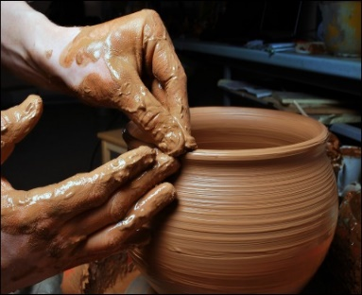Finding the required materials for your craft maybe one of the hardest obstacles that can face you. **Make And Trade** will provide all the users’ materials the need on our website for purchase and it can be delivered to them wherever they are.

**Putting The Product for Sale:**

After finishing the product, the user will be able to sell it in our website, and interested buyers can buy it or contact the uploader personally for a special request. The users’ crafts will also be rated by other users. Users with high ratings will get discounts on the materials

they buy from our website

**System Architecture:**

**Make & Trade** system introduces an amount of handmade crafts and tutorials and purchase service.

The system offer the contents and service to both mobile and desktop users via web-based service.

The system consists of following modules:

**Storage:**

**Make And Trade** uses different types of storage:

● Core storage for the products and user interaction.

● Archive storage for historical changes, deleted contents and old logs.

● System storage for system configuration, users information and fresh logs.

Core storage uses MySQL database that is managed by the website’s backend using php. This will allow us and the users to add new products and tutorials. Php allows us to make the communication with the database easier and accessible to view old content and list them.

**Indexing:**

Automatic indexing will be made by the database for all entries. Full text search is used by final users to find certain contents. Also, it used by other modules like data processing to locate contents in a fixed time regardless the overall contents size.

**Product/Tutorial Creation Area:**

This module provides the user with all tools required to upload his item for sale. User can create a product, categorize it, add specs to it, the material used, his phone number and off course, the required price.

The user can modify the product or its specs, same to the tutorials.

**General User Area:**

This module provides user with main system activities like a link to upload a product, view existing products’ details, search for specific products, buying materials, watching tutorials self-exercising exams or attending an online exams arranged by others.

For each product or tutorial, it is possible for the user to discuss issues with the product owner regarding the product or specific inquiry. Users can comment on every item on the website and rate it.

Users can edit their profiles and view other user’s profiles.

General system support martial are published to help users. However users can communication with system operators to report issues or to get a direct support.

**System Administration Area:**

This module is dedicated for system administrators. System administrators responsible on system management, configuration, backup and solving technical issues. System administrator, can view system status, data status, online sessions, logs and other system status and measures and manage the users and products and tutorials.

**Security:**

Security module is responsible on user authentication and communications security. Users register/login using internal accounts .

Security module also, responsible on managing the permissions and roles. Users are either guests, logged users, examination authority owners and examiners.

# System Features

**Adding products**

The user can put whatever handmade products he made so it can be viewed to other users.

The user will give its product a name and an image, determine the price he wants to sell his product for put a description for his product along with photos of it, also there an option to add videos for this product being used. The type of the product should be determined according to craft categorization.

At any time the user can edit his product, change the description or price.

**Viewing products**

The user will be able to view the different products added by other users, clicking the product will show its description.

By default the products will be viewed by date, however the users can view them according to their ratings or their price.

The users can specify a certain price range for the products they want to be viewed.

The users can choose a specific category of crafts so that only product of that category will be viewed.

The user will be able to search for certain products either by the name of their owner or the name of product itself.

The owners contact information will be viewed alongside their products so that the interested users can contact him about their products.

**Product reviews & comments**

In the Product detail page users will be able to give a rating and it will also include a comment section where users can interact with each other, ask the owner any questions they have and give their opinions about the product.

**Materials**

Materials needed for making handmade crafts will be available for buying by the users at any time.

The users will be able to choose a specific type of materials and determine the price range they like.

After deciding the materials he want the user can determine the quantity he wants of this material.

**Shopping cart**

The users will be able to add the products and the materials they wish to buy to their cart and proceed into shipping and paying methods.

The user cart show him all the products he wishes to buy and any change that happen to these products.

**Paying method**

The user will be able to choose whatever paying method he prefer, he can choose between cash on delivery or paying by a PayPal account.

**Adding Tutorials**

Any user with experience in making handmade crafts, will be able to share it.

The user can add a description to how he was able to make his product, along with the materials he needed and he can also upload videos that explain the process.

**Viewing Tutorials**

The users will be able to view the tutorials made by other users.

The user can search for tutorials either by the name of their uploader or the category of craft they are made for.

**Tutorials reviews & comments**

For any specific tutorial, the users will be able to rate it, also the tutorials will include a comment section where the users can ask the uploader about anything they don’t understand, or even give feedback about his explanations or what they like or don’t like.

**User management**

Users must register to the system before they can add products or tutorials, or buy materials and other user products.

**User profile**

Users are free to do both selling and buying, they can upload tutorials and buy materials.

User profile show the contact information, address, the number of products he added and the number of tutorials.

**User rating**

Users who add tutorials or products will be given points according to the number and rating of their tutorials and products.

Users with high points will be given a discount on the materials they buy.

# System Development and Operation

**Overview**

The system development is performed using Agile methodology. Initial R&D activity should be applied to experiments tools and techniques. Later continuous R&D activity will run beside the system development activities. The first version of the system should take sixteen month. After release, the system will enter an initial operation phase for six months. During that phase the whole development team will communicate directly with the operation & business team. Later the system will enter the final operation and maintenance phase. During that phase a minor dev. team will provide an indirect technical support.

**Development plan**

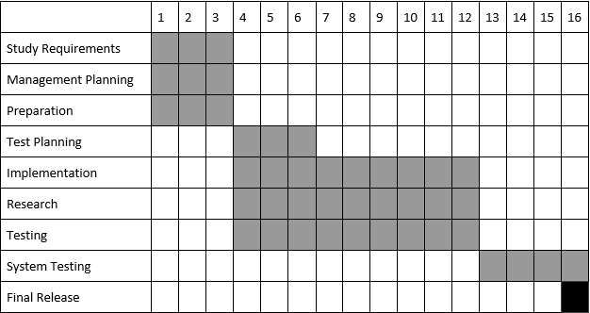

**Operation plan**

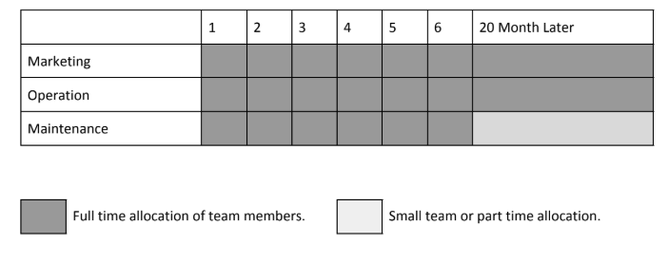

**Tools**

Make and trade will be developed using open source tools, languages and servers. This will decrease the cost especially for long term operation. While development only online tools will be used for management, tracking, testing and source control. This will increase the collaboration between team members even they are not located at the same place. Also, this will allow external teams and members to participate.

|  |  |
| --- | --- |
| Operation | Used tools |
| Source control and versioning | GitHub/Git |
| Tasks and issues tracking | GitHub |
| Structured Database | MySQL |
| Frontend | HTML/CSS/Javascript |
| Backend | php |
| Frameworks | Bootstrap(for frontend) |

**Cost**

-The system completely depends on open source tools and language,

So there wouldn’t be many expenses for development.